check hotel room
Content

- Pseudocode-----------------------------------------------------1
- Flowchart-------------------------------------------------------2
- C++ code-------------------------------------------------------3

1-Pseudocode

This program Built to runs Hotel System.
define function called push to push the rooms into the stack
define function called pop fistly it check if the stack is empty , if its not it will pop the last room in the stack
define function called top fistly it check if the stack is empty , if its not it will display the last room in the stack
define function called enqueue to push the rooms into the Queue
define function called dequeue to pop the front element into the Queue
define function called book_room to finds an available room for a customer to book. If a room is available, it books the room for the customer; if not it adds the customer to the waitlist
define function called vacate_room to Checks if a specified room is occupied. if it is, it vacates the room, allowing for the next customer in the waitlist to be booked into it
define function called print_occupancy to displays the current occupancy status of all rooms in the hotel, indicating whether each room is occupied or vacant
then begin in the main function which will runs the main program loop for managing the hotel, It presents options to book rooms, vacate rooms, view occupancy, and exit the program.
2-Flowchart
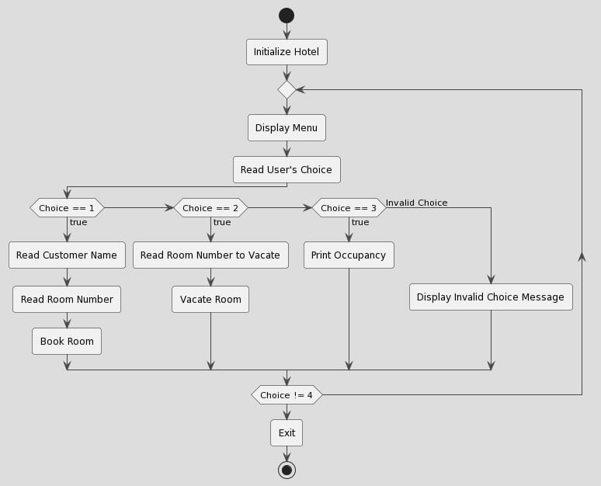

3-code
#include <iostream>
#include <string>
#include <stdexcept>
using namespace std;

struct Customer {
string name;
int roomNumber;
};

class Stack {
private:
struct Node {
Customer data;
Node* next;
Node(const Customer& customer) : data(customer), next(nullptr) {}
};

Node* topNode;

public:
Stack() : topNode(nullptr) {}

~Stack() {
while (!isEmpty()) {
pop();
}
}

void push(const Customer& customer) {
Node* newNode = new Node(customer);
newNode->next = topNode;
topNode = newNode;
}

Customer pop() {
if (isEmpty()) {
throw runtime_error("Stack is empty");
}
Node* temp = topNode;
Customer data = temp->data;
topNode = topNode->next;
delete temp;
return data;
}

Customer top() const {
if (isEmpty()) {
throw runtime_error("Stack is empty");
}
return topNode->data;
}

bool isEmpty() const {
return topNode == nullptr;
}
};

class Queue {
private:
struct Node {
Customer data;
Node* next;
Node(const Customer& customer) : data(customer), next(nullptr) {}
};

Node* frontNode;
Node* rearNode;

public:
Queue() : frontNode(nullptr), rearNode(nullptr) {}

~Queue() {
while (!isEmpty()) {
dequeue();
}
}

void enqueue(const Customer& customer) {
Node* newNode = new Node(customer);
if (isEmpty()) {
frontNode = newNode;
rearNode = newNode;
} else {
rearNode->next = newNode;
rearNode = newNode;
}
}

Customer dequeue() {
if (isEmpty()) {
throw runtime_error("Queue is empty");
}
Node* temp = frontNode;
Customer data = temp->data;
frontNode = frontNode->next;
if (frontNode == nullptr) {
rearNode = nullptr;
}
delete temp;
return data;
}

bool isEmpty() const {
return frontNode == nullptr;
}
};

class Hotel {
private:
Stack rooms[3];
Queue waitlist;

public:
void bookRoom(const Customer& customer) {
int availableRoom = -1;
for (int i = 0; i < 3; ++i) {
if (rooms[i].isEmpty()) {
availableRoom = i;
break;
}
}

if (availableRoom != -1) {
rooms[availableRoom].push(customer);
cout << "Room " << availableRoom + 1 << " booked for " << customer.name << endl;
} else {
waitlist.enqueue(customer);
cout << "All rooms are occupied. Added " << customer.name << " to the waitlist." << endl;
}
}

void vacateRoom(int roomNumber) {
if (roomNumber < 1 || roomNumber > 3) {
cout << "Invalid room number." << endl;
return;
}

if (!rooms[roomNumber - 1].isEmpty()) {
rooms[roomNumber - 1].pop();
cout << "Room " << roomNumber << " vacated." << endl;

if (!waitlist.isEmpty()) {
Customer nextCustomer = waitlist.dequeue();
rooms[roomNumber - 1].push(nextCustomer);
cout << "Room " << roomNumber << " booked for " << nextCustomer.name << " from the waitlist." << endl;
}
} else {
cout << "Room " << roomNumber << " is already vacant." << endl;
}
}

void printOccupancy() {
cout << "Current Occupancy:" << endl;
for (int i = 0; i < 3; ++i) {
if (!rooms[i].isEmpty()) {
cout << "Room " << i + 1 << ": Occupied by " << rooms[i].top().name << endl;
} else {
cout << "Room " << i + 1 << ": Vacant" << endl;
}
}
}
};

int main() {
Hotel hotel;
int choice;
do {
cout << "1. Book Room\n2. Vacate Room\n3. Print Occupancy\n4. Exit\n";
cout << "Enter your choice: ";
cin >> choice;

switch (choice) {
case 1: {
string name;
cout << "Enter customer name: ";
cin >> name;
hotel.bookRoom({name, 0}); // Room number is not required when booking
break;
}

case 2: {
int roomNumber;
cout << "Enter room number to vacate: ";
cin >> roomNumber;
hotel.vacateRoom(roomNumber);
break;
}
case 3:
hotel.printOccupancy();
break;
case 4:
cout << "Exiting..." << endl;
break;
default:
cout << "Invalid choice. Please try again." << endl;
}
} while (choice != 4);

return 0;}

